**1. Introduction to Project**

**INTRODUCTION**

The current system is user friendly and easy to use. In this system we give all information about BrandZone Men’s Wear. that is what type of product and services provided by them.

The main purpose of this project is that to provide facility to website owner to sell their BrandZone Men’s Wear Online. Customer can access information about BrandZone Men’s Wear. from their home or from anywhere via internet through mobiles or computers. In this project customer can watch and browse every categories of BrandZone Men’s Wear Online Website. In this system feedback facility is also provided to user. User can provide their feedback and suggestions to us then it is easy to change in system according to user’s suggestions.

The System helps to customer to purchase the product without debit or credit card information because of cash on delivery facility. This website will helpful to customer who wants to purchase items using internet. This system is developed as per owner requirement.

1. **Existing System**

* Existing system for Men’s Wear shopping is available online but some limitation. They don’t provide online purchase facility.
* In the existing system all transactions, dealing of products, purchasing of products were done manually which is time consuming.
* To buy any product user has to collect information about it either by visiting the shop or asking people which is the better one.
* All transactions are performed manually which may not be accurate always.
* If they want to do so requires more manpower for advertising purpose. Or to distributes pamphlets in newspapers. So, it is time consuming process.
* All records are maintained on paper.

**B) Need and Scope of Computerized System**

Due to following reasons and to overcome problems in existing system it is necessary to develop new computerized system.

* To make Existing system online for owner to sell their Appeals online.
* To advertise newly started services, offers, newly arrived Accessories.
* To maintain all records regarding all customers and products.
* Allows user to get registered from their places and transact for the required product.
* To save manpower and time.
* To make all information available within one click.

`

**C**) **PURPOSE OF SYSTEM**

The main objectives of the proposed website are to reduce the manual paper work and making mobile buying easy.

The system removes possibility of any erroneous reading to occur as it first validates the fed to it Reduce the manual paperwork. To provide fast access & past data backup facility is provides. This System is time saving & User Friendly.

In the proposed system primarily focuses on building an efficient and user-friendly Website. The website is for online buyer. It intends to provide an interface to the buyer who will require minimal details to input for buying a fashion accessory easily which he wants. Apart from that, the website would support strong user authentication and quick transmission of data via the web service. Another noticeable feature of the entire website would be that all databases should be easily managed.

The system effectively maintains whole data. The system works fast, save time and gives more accurate data processing. The system gives detail information about manual product sales plan.

Using this system, advertising will be done effectively. This system is helpful to fashion accessories to reach customer with just one click from their house.

This website can be accessed by the customer for 24 *7 hours. The information of products and services could be viewed by the customer or buyers on their mobile phones and computer system and it requires internet connection. This web site is useful for the Clothing Stores because it is possible to quickly launch any new product and services of the appeals on their website.

**2. Proposed System**

1. **Objectives of proposed System**

Following are the objectives of proposed System

* To provide facility to website owner to sell their product online.
* To provide online purchasing facility to customer for 24*7 hours.
* To provide online information about different products to customer.
* To provide facility to use as an effective advertising media.
* Maintains all records regarding customers and products.
* Allows user to get registered from their places and transact for the required product.
* To save manpower and time.
* To reach customer with just one click.
* shop wile in the comfort of your own home, without having to step out of the door
* To be able to easily save money and compare prices from website to website
* Online resellers tent to sell at a lower price due to less overhead expenses

**B) FACT FINDING TECHINQUE**

1. **On Site Observation :-**

Drawbacks of the existing system were noted down. The client specification was taken into considerate

1. **Other Sources :-**

The company has been visited many items, which helped in getting the precious information, input output Also helped in developing good human relation with company staff and management**.**

1. **Interview:**

Many people from different section have been interview and respective information has been collected from them. This one of the important requirement determination technique used as it provided with lot of information. Help in knowing the positive and the negative points along with the additional features that the user wants in the system.

Requirement determination technique focuses on various information structural and procedure details of the current system. It helped in identifying various input and output. The entire system also evaluates client as a human being, which was helped designing the system and providing graphical user interface.

**C**) **FEASIBILITY STUDY**

The Feasibility Study is the one that lets our proposed work to put into real action.

This relates with whether our system performance is best or not, it worth’s or not, etc. It actually points to whether the user requirements are getting fulfilled or not. The feasibility study play a major role in the analysis of the system. The feasibility forms the basis of the system

We are having three different feasibility types for the feasibility study as follows:

**1) Technical Feasibility :-**

If the system processes huge amount of data then the System is technically feasible. Technical evaluation must also access whether the existing system can be upgraded to use the new technology & whether the organization has the expertise to use it.

**2) Economic Feasibility:-**

Economic feasibility consider the cost & benefits analysis of the proposed the project. The benefit is always expected to be over the cost .Automation leads to cost reduction and beneficial to cost analysis of the system. Economically, the system is capable of purchasing the required setup. Automation results in the reduction of manpower and processing time.

**3) Operational Feasibility:-**

Operational feasibility consider the acceptability of the system. The project can be rejected due to operational non feasibility. Will the system be used if it developed and implemented ? Will there be a resistance from the user to the new system. The system will provide timely information and status of the various activities to manage, to facilitate the user of the system. The product can operate smoothly in all type of environmental.

Thus, it is concluded that the system is technically, economically and operationally feasible.

**C**) **TECHNOLOGY USED**

**1. Net Framework 4.0:-**

Microsoft .Net Framework is complex technology that provides infrastructure for building running and managing next generation applications in a layered representation, the .Net framework is a layered positioned between the Microsoft window operating system and your application .Net is platform but also is defined as a technology because it is composed of several parts such as libraries, executable tools, and relationships and integrates with the operating system.

* .Net framework is a complete environment that allow developers to develop , run and deploy
* the following applications :

1. Web application (ASP.NET application).
2. Web services.

The .Net framework 4.0 is instead a complete standalone technology that does not require other previous versions to be installed.

**2. HTML (Hyper Text Mark-up Language):-**

Html is document-layout and hyperlink specification language .It defines the syntax and placement of special embedded directions that are not displayed by the browser, but tell it to display the content of the document including text, images and other supported media. The

HTML language also tells you how to make a document interactive through special hypertext links, which connect your document with other documents on either your computer or someone else’s as well as with other Internet resources like FTP .

**3. CSS (Cascading Style Sheet):-**

Style sheet separates the document structure from its presentation. Once you made fully structured HTML document the how to present it is decided by creating specific style sheet for that document

**4. MS Access:**

Used Ms Access database 2010.Ms Access to use for save the data in the database.

Database used stored and retrieve data from the database.

**3. System Analysis**

**A) DIAGRAM**

**WEB LINK DIAGRAM**

HOME

View Details

View Details

ABOUT US

View Details

PRODUCTS

Home Page

FEEDBACK

CONTACT US

User Login

LOGIN

Customer Login

PRODUCTS

VIEW REGISTRATION

Master Page

2

VIEW FEEDBACK

VIEW ORDER

LOGOUT

* Data Flow Diagram:
* Level or context level DFD :-

Product 0.0 Personal detail &

Detail select product

User

Admin

BrandZone

Men’s Wear

Order Details Order Receipt and

Confirmation

***2)* 1st level DFD**

* **For Admin**

**1.0**

**Login**

Request for login

Response

**2.0**

**Manage Product**

Store& retrieve Data

**Insert/Update/Delete** Product

**Admin**

**3.0**

**View order**

Response Retrieve Data

Purchase

View Registration

**4.0**

**View Registration**

Retrieve Data

Login

**5.0**

**View Feedback**

View Feedback Retrieve Data

FeedBack

Response

**FIRST LEVELDFD FOR USER**

**1.0**

**Item search**

Search Item Product

Response Retrieve Data

Make registration

**2.0**

**Registration**

Store Data Login

Store Data Response

**3.0**

**Login**

Make Login Validate Data

Login

Response

**4.0**

**Display Product**

View Product Retrieve Data Products

**USER**

Response

**5.0**

**Buy Product**

Buy Product Store Data

Products

Confirmation

**6.0**

**Purchase**

Receive Order list Retrieve Data

Bill

**3.2 Entity Relationship Diagram**

Gives

Admin

M

Customer

M 1 1

View

M

Feedback

View & Order

Generate

M

Send To

M

Product

Bill

1

Managed

By

M 1

**4. System Design**

1. **DATABASE DESIGN :-**

A database is an organized mechanism that has the capability of storing information through which a user can retrieve stored information in an effective and efficient manner. The data is the purpose of any database and must be protected.

The database design is a two level process. In the first step, user requirements are gathered together and a database is designed which will meet these requirements as clearly as possible. This step is called Information Level Design and it is taken independent of any individual DBMS that will be used to implement the system in question. This step is called Physical Level Design, concerned with the characteristics of the specific DBMS that will be used. A database design runs parallel with the system design; the organization of the data in the database is aimed to achieve the following two major objectives.

* + Data Integrity
  + Data Independence
  + Normalization is the process of decomposing the attributes in an application, which results in a set of tables with any simple structure. The purpose of normalization is to make tables as simple as possible. Normalization is carried out in this system for the following reasons.
* To structure the data so that there is no repetition of data, this helps in saving.
* To permit simple retrieval of data in response to query and request.
* To simplify the maintenance of the data through updates, insertions, deletions.
* To reduce the need to restructure or reorganize data which new application requirements arises.

**LoginPage Table:-**

|  |  |  |
| --- | --- | --- |
| **Column Name** | **Data Type** | **Constraints** |
| Cid | numeric(18,0) | Primary Key |
| Cname | nvachar(50) | Null |
| Cpassword | nvachar(50) | Null |

**FeedbackForm Table-**

|  |  |  |
| --- | --- | --- |
| **Field Name** | **Data Type** | **Constraints** |
| cid | numeric(18,0) | Primary Key |
| Name | nvarchar(50) | Not Null |
| Message | nvachar(50) | Not Null |
| Email | nvachar(50) | Not Null |

**ProductForm Table:-**

|  |  |  |
| --- | --- | --- |
| **Field Name** | **Data Type** | **Constraints** |
| Pid | numereic(18,0) | Primary Key |
| Pname | nvachar(50) | Not Null |
| EnterRate | numereic(18,0) | Not Null |
| UploadImage | nvarchar(max) | Not Null |
| Quantity | numeric(18,0) | Not Null |
| EnterProductInfo | nvachar(50) | Not Null |

**RegistrationData Table**

|  |  |  |
| --- | --- | --- |
| **Column Name** | **Data Type** | **Constraints** |
| cid | numeric(18,0) | Primary Key |
| Name | nvarchar(50) | Not Null |
| Mobile | numeric(18,0) | Not Null |
| Address | nvachar(50) | Not Null |
| Email | nvachar(50) | Not Null |
| Uname | nvachar(50) | Not Null |
| Password | nvachar(50) | Not Null |

B) SCREEN SHOTS **(user side):**

Home Page:

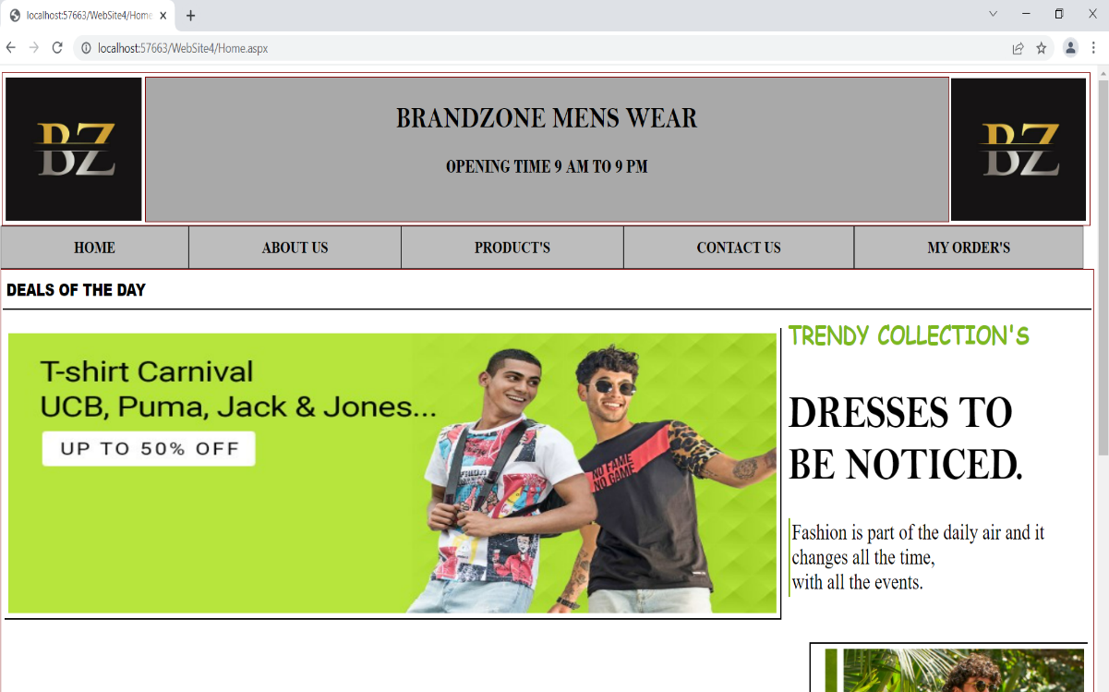

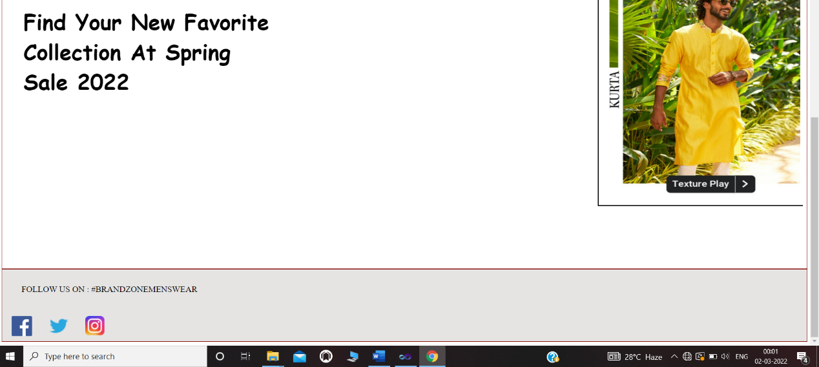

About US:

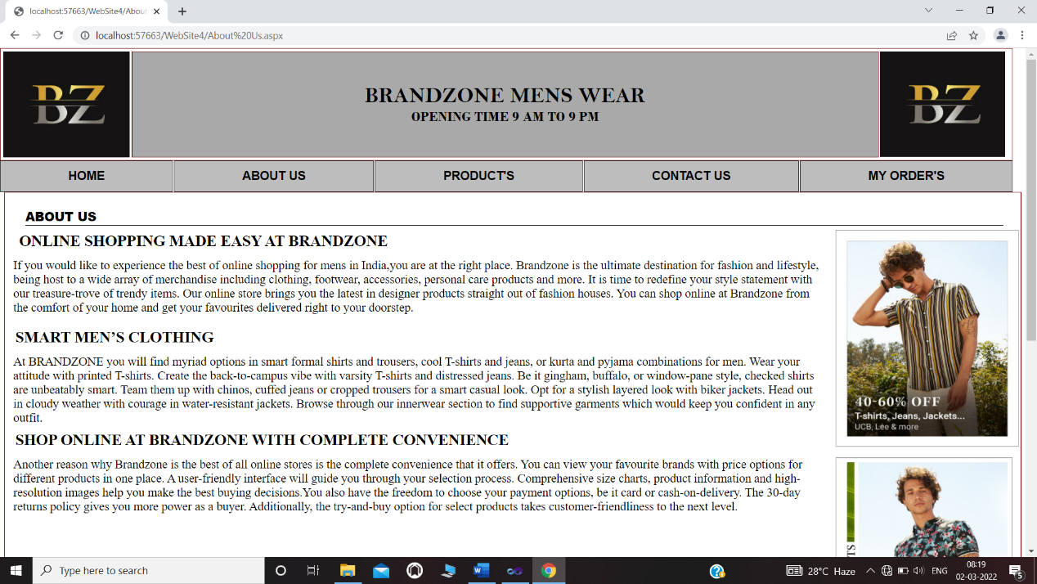

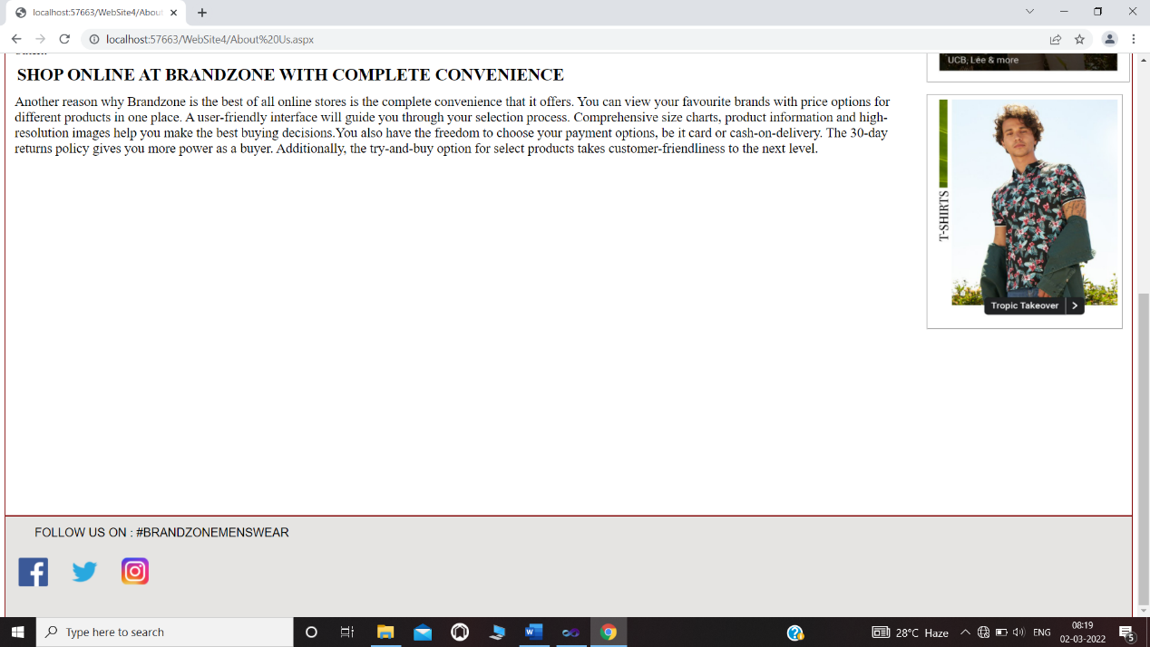

Products:

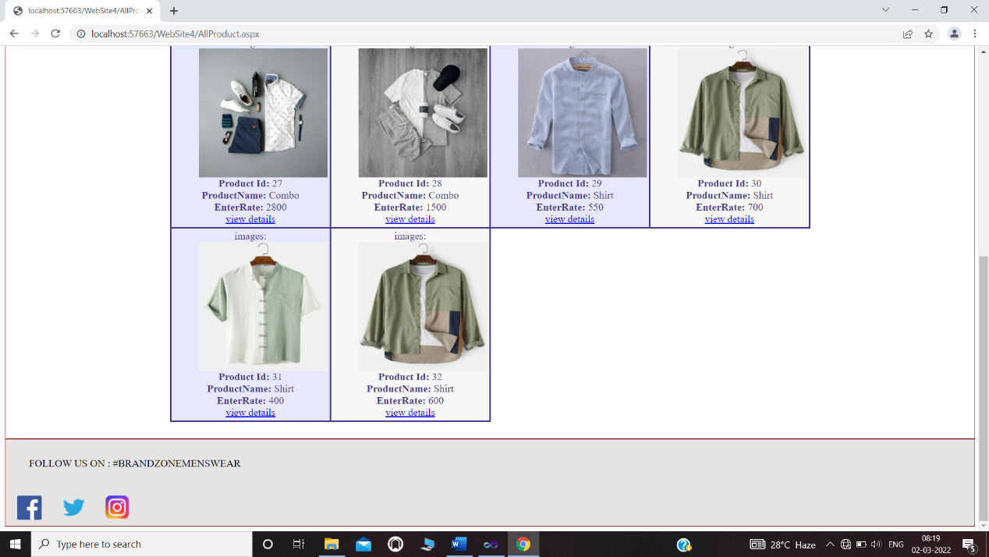

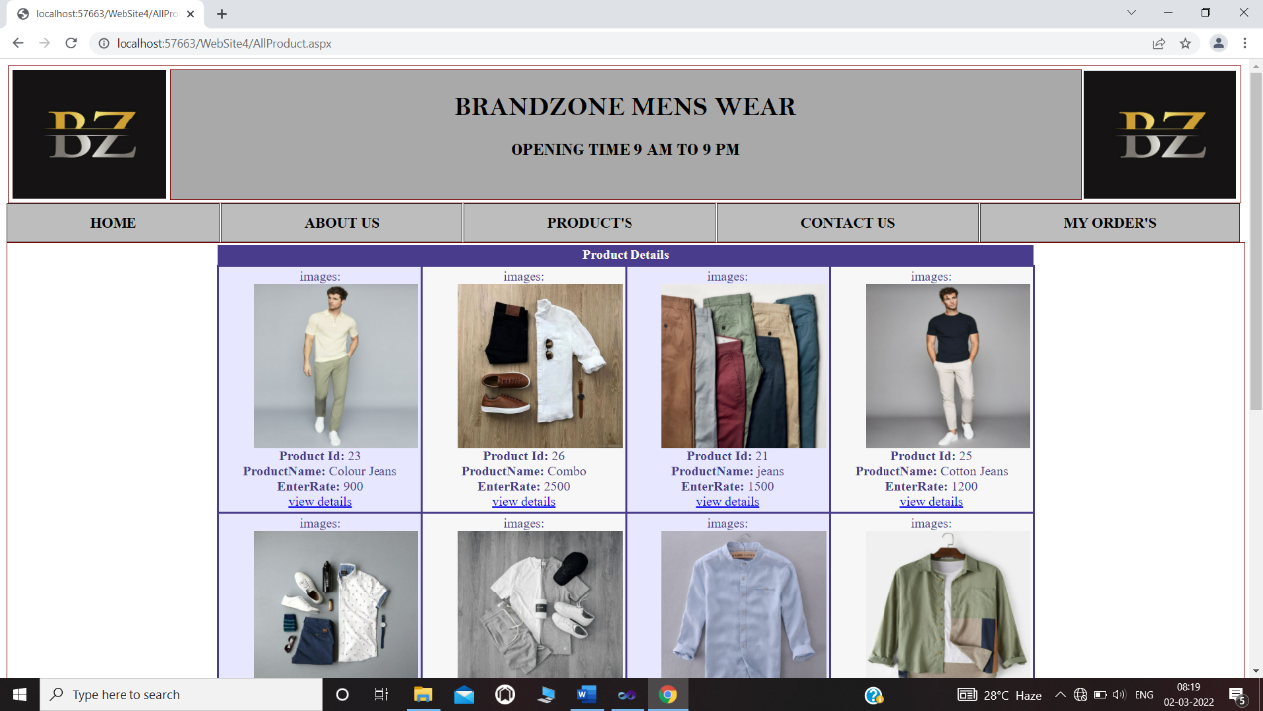

Single product Page:

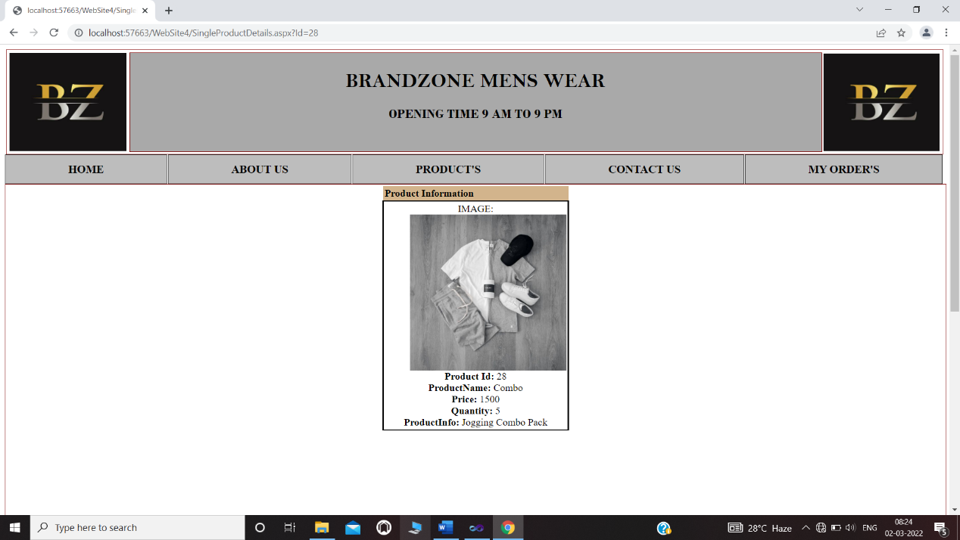

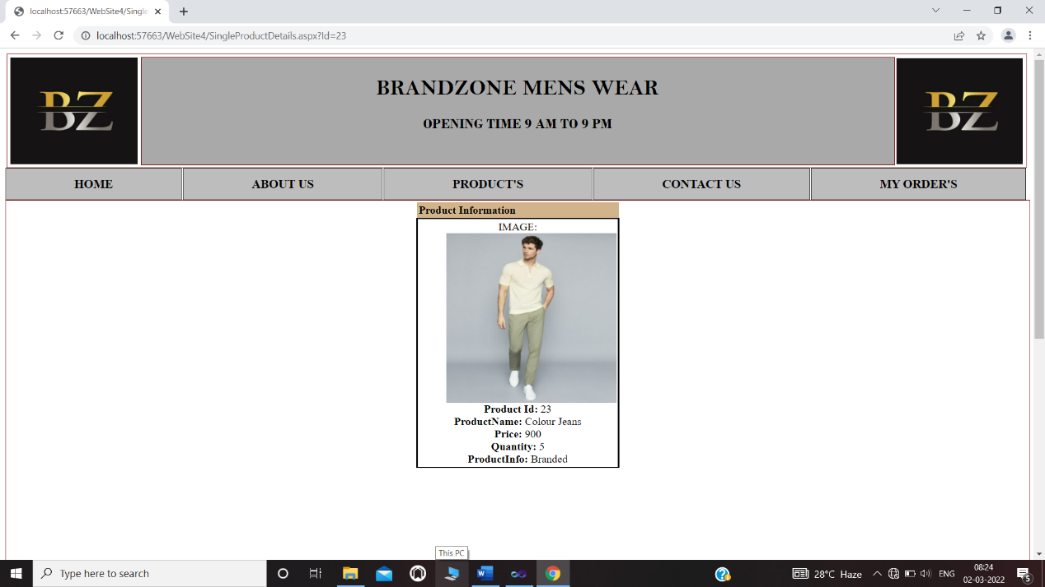

Contact Us Page:

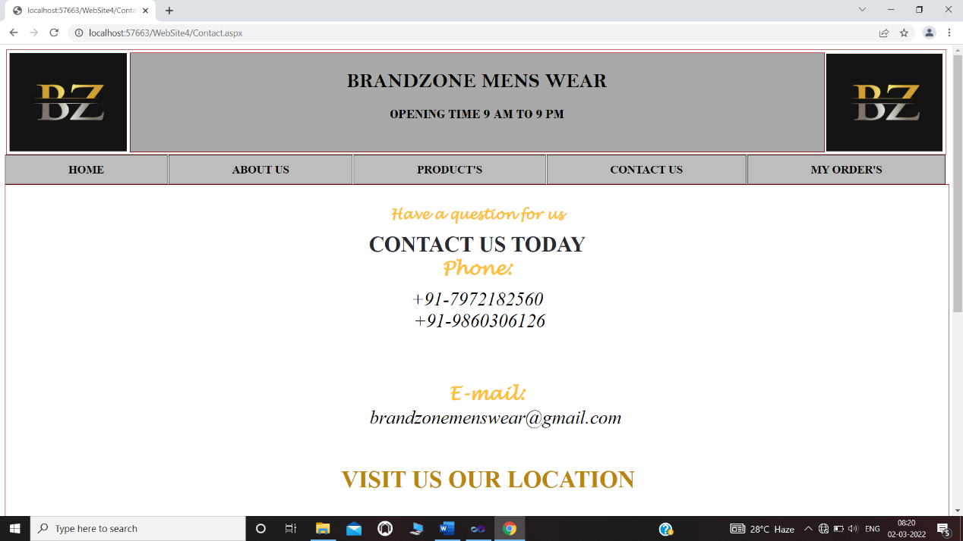

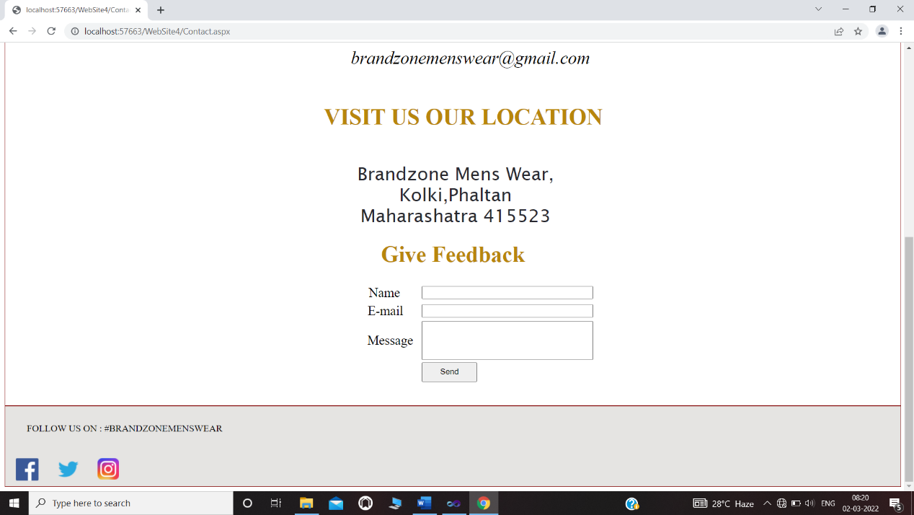

Login Page:

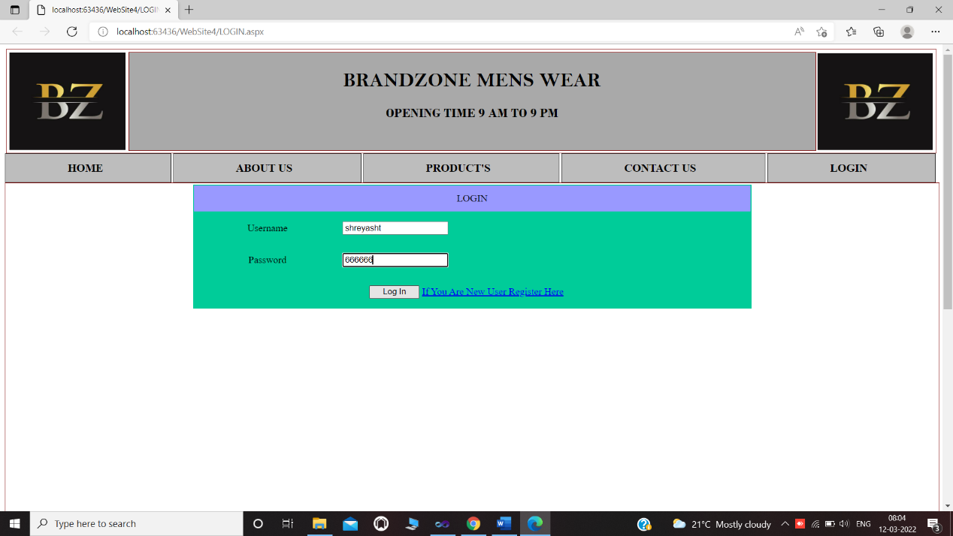

Login Page: Incorrect User Name Password

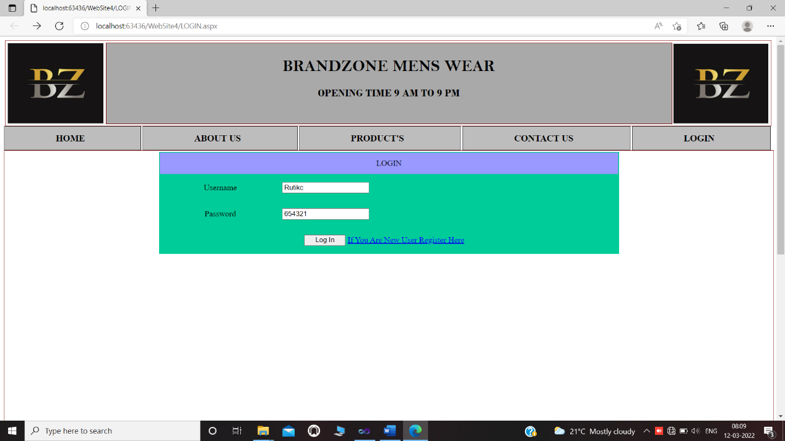

Login Process: Your User Name Password Incorrect

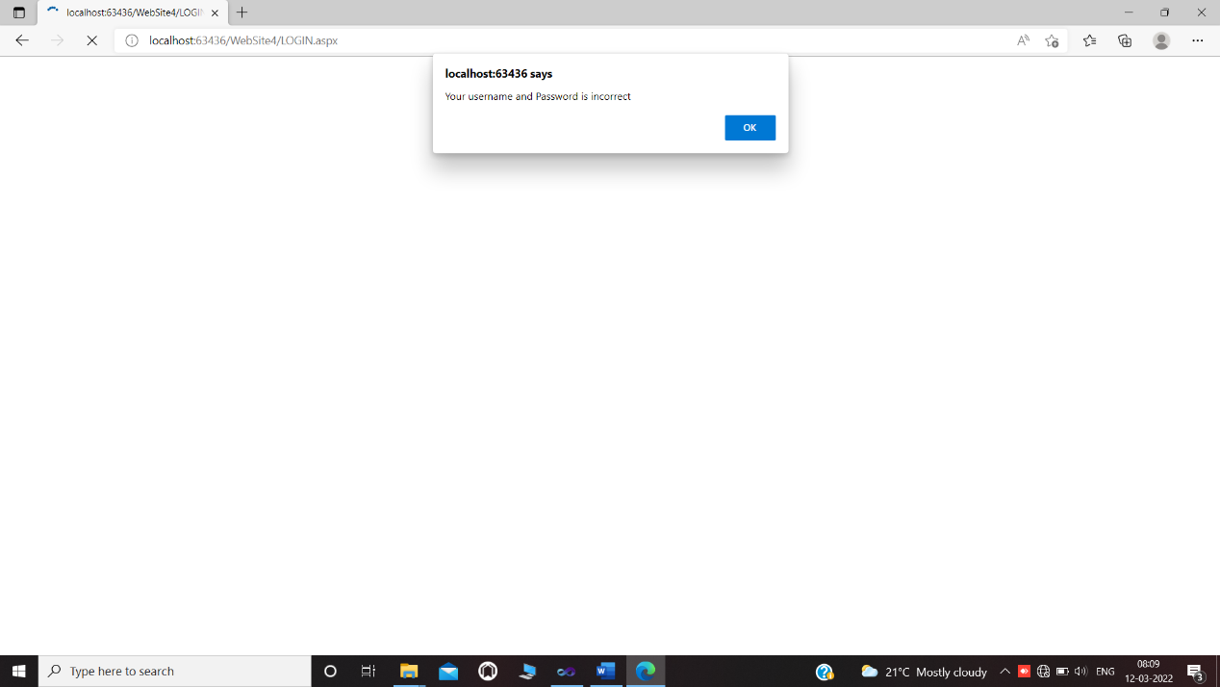

Add Product:

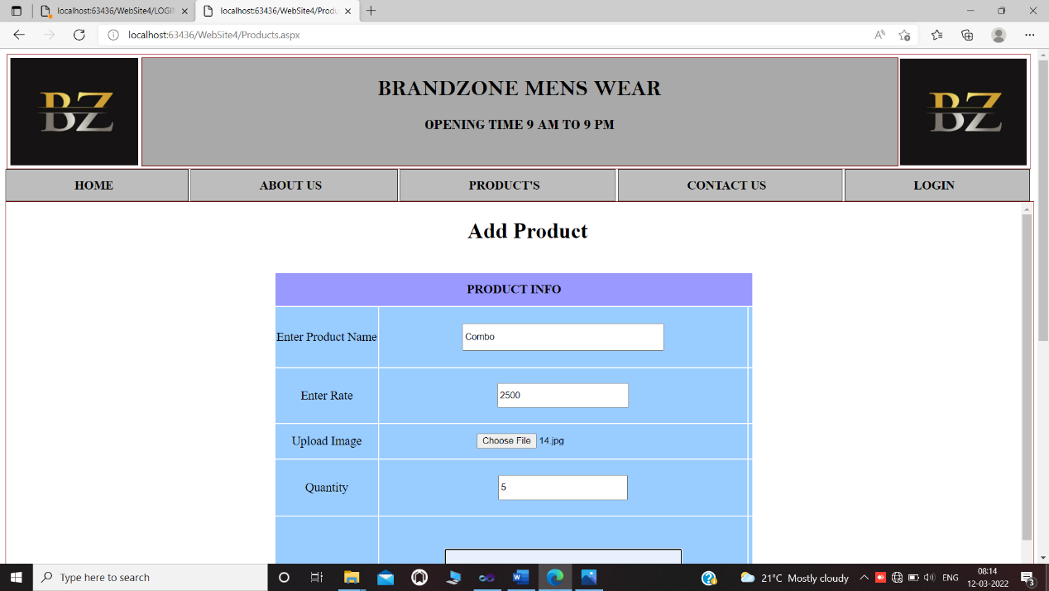

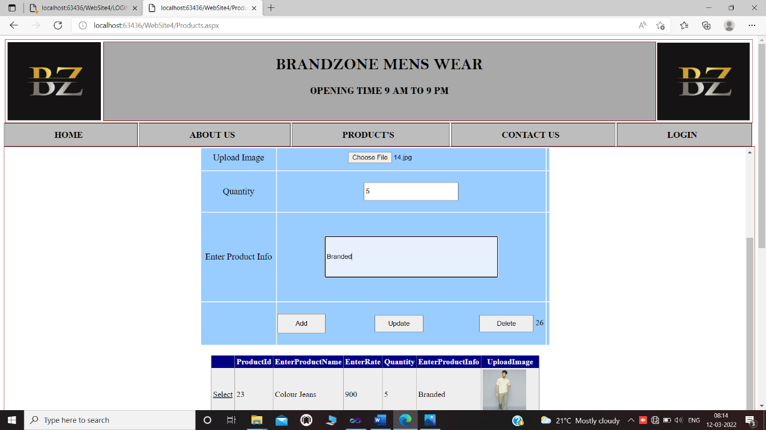

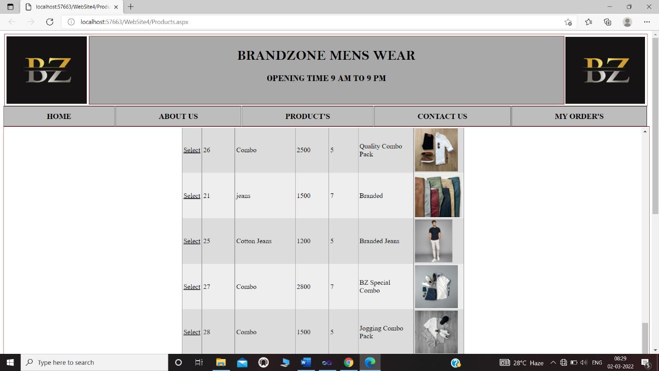

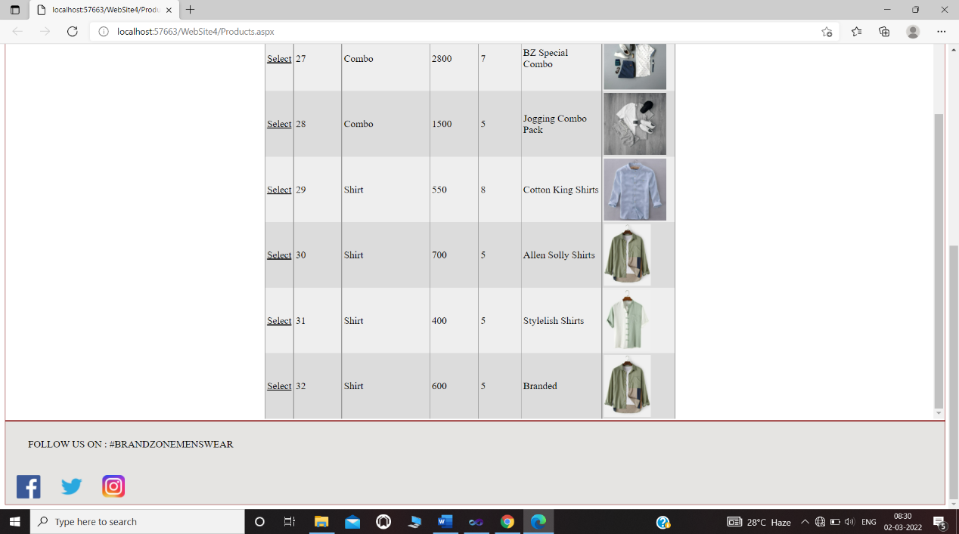

**Admin Master:**

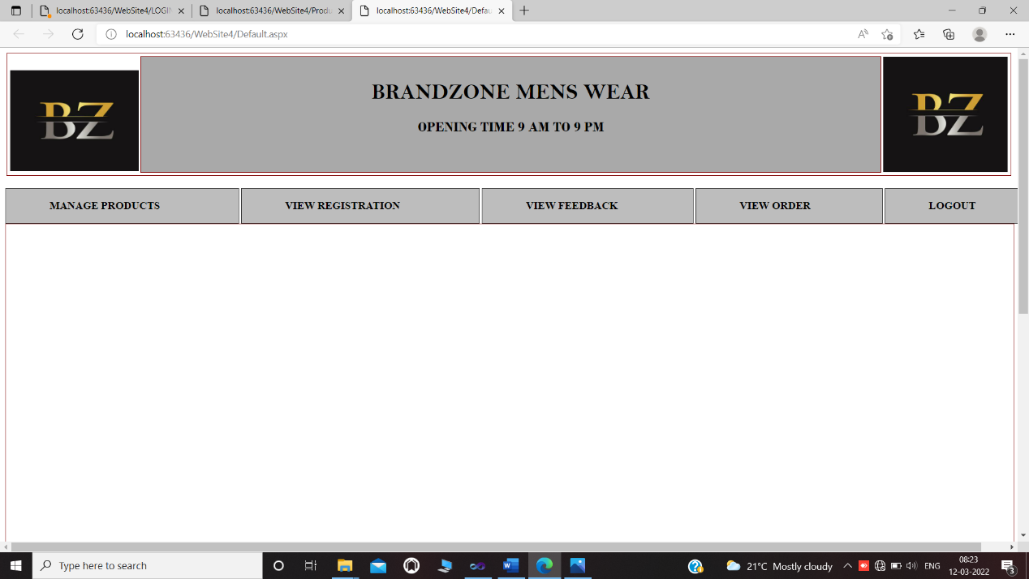

**Manage Product:**





**View Registration:**

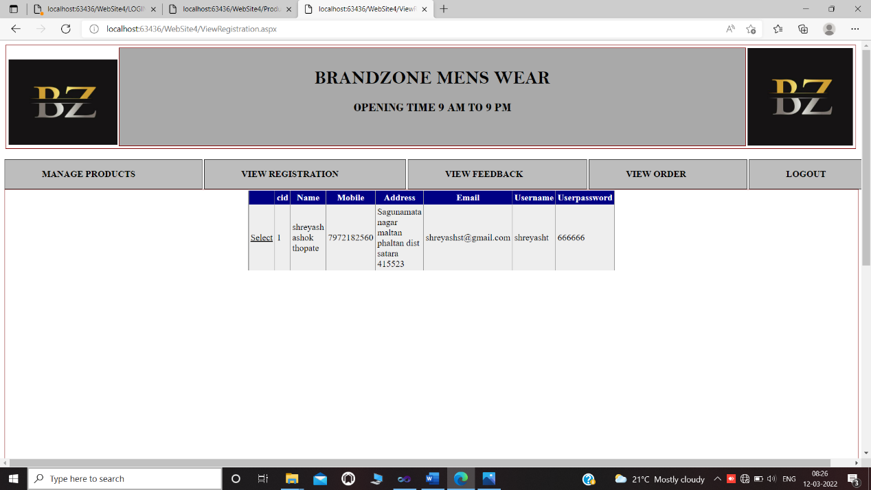

**VIEW FEEDBACK:**

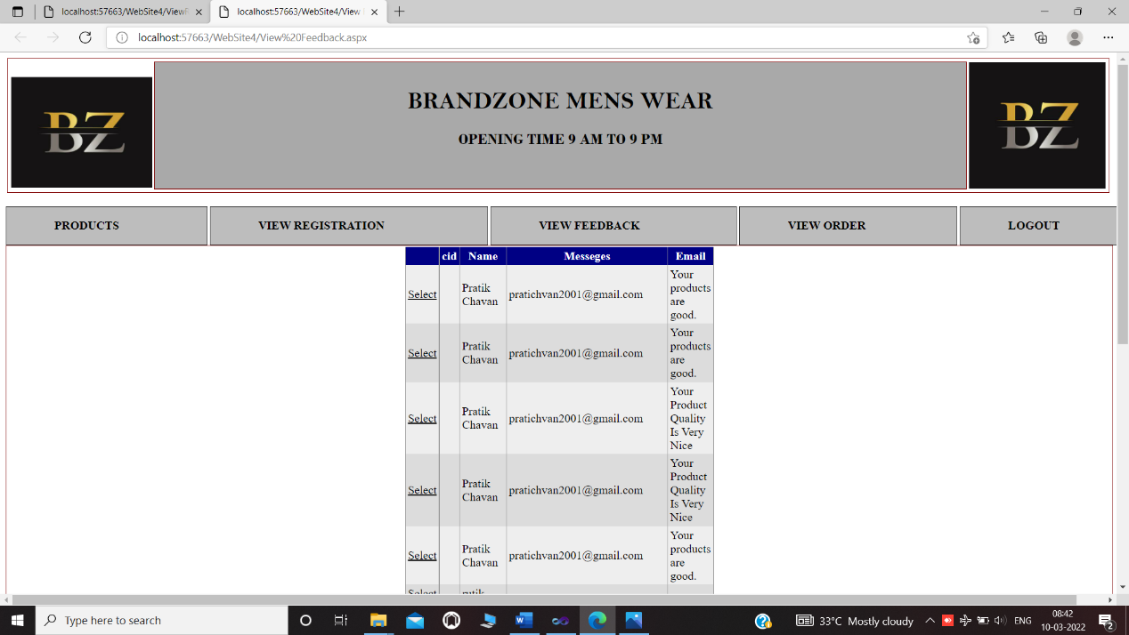

**Implementation**

1. **System Requirement:-**

* **Hardware-**
* Processor : Pentium4 or as above
* Hard disk : 40 GB
* Memory : 4GB or above
* Printer
* **Software-**
* Operating system: Windows XP or above.
* Development database: MS-Access 2010 as backend tool.
* Browser: Mozilla Firefox, Internet Explorer, Google Chrome.
* Microsoft visual studio 2010 as front end tool.

1. **User Guideline:-**

In our project there are many menus and this user manuals helps user to find the information easily.

**Home:-**If user wants to go on home then user can click on home Menu.

**About us:-**

About us menu provide information about BrandZone Mens Wear .

**Contact Us:-**

Contact us menu provide contact details of online BarndZone Mens Wear.

Feedback provides facility to user to record their feedbacks.

**Products:-**

When user want to access the information about the products then click on Categories menu

**Login:-**

Registration menu provides facility to user for registration.

**Number of Modules:**

**1. Admin**

**2. User**

**Admin:-**

The administrator is the super user of this application. Admin only access to enter this admin page. Admin had all privileges to give privileges to give authenticate to user and gives privileges that which portion they can access . The administrator has all the information about all the users and all products.

This module is divided into different sub-modules.

1. Add products.

2. View Orders.

3. View feedback.

4. View User.

**Manage Products**

**Add products:**

Admin can add new products into the existing system.

**Delete products**:

If the admin want to the delete products then he can delete the products.

**View Feedback:**

Admin can view the user feedback which sends by a customer or users.

**View the users:**

Administrator can view the registration history which is registered by the user.

**User:-**

**View products:**

Users can view the products based on their varieties. A detailed description of a particular product can be displayed to the user, product name, price, manufactured, and expiry date of products, etc…

**Sign up:**

if user wants to buy any product, then he first fill up registration form. After registration user get username and password.

**Login:**

With the help of username and password user can login and purchase the product.

**Conclusion & Suggestions**

**A) Conclusion: -**

1. **Easy To Understand: -**The structure of the system marks it easy to understand and operate the whole system.
2. **User Friendly: -**The system is user friendly and data can be backup and recovery easily.
3. **System Reliability: -** The system is easy to understand and designed in a user-friendly user. It takes the less amount of time to understand the basic concept of operation.
4. **Time Saving: -** Our system saves more time than the Existing system.
5. **Better GUI: -** We tried to provide best Graphical User Interface
6. **Secure: -**We provide more security to prevent from hackers.
7. System is flexible you can generate more reports and screens as and when required.
8. System is modified in future as per owner requirement

**B) Limitation**

1) No facility of online payment

2) No SMS alert facility.

3) Supports only English language, cannot support regional language.

4) Internet connectivity is required for purchasing product.

5) Peoples who are not familiar with computer cannot purchase product

**C) Suggestion**

1) Provide Support for Regional Languages.

2) Provide SMS alert facility.

3) Provide online payment facility.

**References**

**A) Books**

1) Software Project Management - Edwin Bennatan

2) ASP.NET Black Book -Steven Holzner

3) Software Engineering -Roger s pressmen

**B) Web**

[www.projectabstract.com](http://WWW.ProjectAbstract.com)

[www.w3school.com](http://WWW.W3school.com)

[www.aspnetzero.com](http://WWW.Aspnetzero.com)

**C) Source Code**

**Master page:**

<%@ Master Language="C#" AutoEventWireup="true" CodeFile="MasterPage.master.cs" Inherits="MasterPage" %>

<!DOCTYPE html PUBLIC "-//W3C//DTD XHTML 1.0 Transitional//EN" "http://www.w3.org/TR/xhtml1/DTD/xhtml1-transitional.dtd">

<html xmlns="http://www.w3.org/1999/xhtml">

<head runat="server">

<title></title>

<asp:ContentPlaceHolder id="head" runat="server">

</asp:ContentPlaceHolder>

<style type="text/css">

.style1

{

width: 189px;

}

.style2

{

width: 1100px;

}

</style>

</head>

<body>

<form id="form1" runat="server">

<div>

<asp:ContentPlaceHolder id="ContentPlaceHolder1" runat="server">

<table width=1500px align="center" style="border: medium double #800000" >

<tr>

<td class="style1">

<img src="LOGO.jpeg" style="height: 157px; width: 187px" />

</td>

<td align="center" class="style2"

style="font-family: 'Bell MT'; font-size: xx-large; font-weight: bolder; color: #000000; background-color: #A9A9A9; border: medium double #800000">

BRANDZONE MENS WEAR

<BR>

<h3 style="color: #000000; font-size: 21px; font-family: 'Bodoni MT';">

OPENING TIME 9 AM TO 9 PM</h3>

</td>

<td>

<img src="LOGO.jpeg" style="height: 156px; width: 186px; margin-left: 0px" />

</td>

</tr>

</table>

</asp:ContentPlaceHolder>

</div>

<div style="margin:0px 0px; padding:0px 0px" >

<asp:ContentPlaceHolder id="ContentPlaceHolder2" runat="server">

<asp:Menu ID="Menu3" runat="server" Orientation="Horizontal"

RenderingMode="Table" width=1500px onmenuitemclick="Menu3_MenuItemClick1">

<DynamicHoverStyle BackColor="#CCCCCC" ForeColor="Black" />

<DynamicMenuItemStyle BackColor="#999999" ForeColor="White"

HorizontalPadding="100px" VerticalPadding="12px" Font-Bold="True" />

<DynamicMenuStyle BackColor="Silver" />

<Items>

<asp:MenuItem Text="HOME " Value="HOME" NavigateUrl="~/Home.aspx"></asp:MenuItem>

<asp:MenuItem Text="ABOUT US" Value="ABOUT US" NavigateUrl="~/About Us.aspx"></asp:MenuItem>

<asp:MenuItem Text="PRODUCT'S" Value="CATEGORIES"

NavigateUrl="~/AllProduct.aspx">

</asp:MenuItem>

<asp:MenuItem Text="CONTACT US" Value="CONTACT US" NavigateUrl="~/Contact.aspx"></asp:MenuItem>

<asp:MenuItem Text="MY ORDER'S" Value="MY ORDER" NavigateUrl="~/LoginPage.aspx"></asp:MenuItem>

</Items>

<StaticHoverStyle BackColor="Silver" ForeColor="White" />

<StaticMenuItemStyle BackColor="#BDBDBD" Font-Bold="True" Font-Size="Large"

ForeColor="Black" HorizontalPadding="100px" VerticalPadding="12px" BorderStyle="Groove" BorderWidth="1 px" />

</asp:Menu>

</asp:ContentPlaceHolder>

</div>

<div style="border: medium double #800000; width: 1500px; height: 950px; margin:0 auto; overflow: auto">

<asp:ContentPlaceHolder id="ContentPlaceHolder3" runat="server">

</asp:ContentPlaceHolder>

</div>

<div style="background-color: #E5E4E2; width: 1500px; color: #000000; margin:0 auto; border: medium double #800000; height: 130px">

<asp:ContentPlaceHolder id="ContentPlaceHolder4" runat="server">

<p style="padding: 10px; height: 18px; width: 1469px;">

&nbsp;&nbsp;&nbsp;&nbsp;&nbsp; FOLLOW US ON&nbsp;:&nbsp;#BRANDZONEMENSWEAR</p>

<img src="facebook.png"

style="padding: 15px; height: 38px; width: 39px; margin-top: 0px;"

align="left" />

<img src="twitter.png" style="padding: 15px; height: 37px; width: 39px"

align="left" />&nbsp;

<img src="insta.png" style="padding: 15px; height: 36px; width: 36px"

align="left" />

</asp:ContentPlaceHolder>

</div>

</form>

</body>

</html>

**MASTER PAGE SECOND:**

<%@ Master Language="C#" AutoEventWireup="true" CodeFile="MasterPageNew.master.cs" Inherits="MasterPageNew" %>

<!DOCTYPE html PUBLIC "-//W3C//DTD XHTML 1.0 Transitional//EN" "http://www.w3.org/TR/xhtml1/DTD/xhtml1-transitional.dtd">

<html xmlns="http://www.w3.org/1999/xhtml">

<head runat="server">

<title></title>

<asp:ContentPlaceHolder id="head" runat="server">

</asp:ContentPlaceHolder>

<style type="text/css">

.style1

{

width: 189px;

}

.style2

{

width: 1100px;

}

</style>

</head>

<body>

<form id="form1" runat="server">

<div>

<asp:ContentPlaceHolder id="ContentPlaceHolder1" runat="server">

<asp:ContentPlaceHolder id="ContentPlaceHolder2" runat="server">

<table width=1500px align="center" style="border: medium double #800000" >

<tr>

<td class="style1">

&nbsp;<img src="LOGO.jpeg" s&nbsp;<img src="LOGO.jpeg"

style="height: 151px; width: 192px; margin-left: 0px; margin-top: 0px;" /></td>

<td align="center" class="style2"

style="font-family: 'Bell MT'; font-size: xx-large; font-weight: bolder; color: #000000; background-color: #A9A9A9; border: medium double #800000">

BRANDZONE MENS WEAR

<BR>

<h3 style="color: #000000; font-size: 21px; font-family: 'Bodoni MT';">

OPENING TIME 9 AM TO 9 PM</h3>

</td>

<td>

<img src="LOGO.jpeg" style="height: 172px; width: 186px; margin-left: 0px" />

</td>

</tr>

</table>

</asp:ContentPlaceHolder>

</asp:ContentPlaceHolder>

</div>

&nbsp;&nbsp;&nbsp;

<asp:Menu ID="Menu1" runat="server" Font-Bold="True" ForeColor="Black"

Orientation="Horizontal" Width="1550px" RenderingMode="Table">

<Items>

<asp:MenuItem Text="PRODUCTS" Value="PRODUCTS" NavigateUrl="~/AllProduct.aspx"></asp:MenuItem>

<asp:MenuItem Text="VIEW REGISTRATION" Value="VIEW REGISTRATION"

NavigateUrl="~/ViewRegistration.aspx"></asp:MenuItem>

<asp:MenuItem Text="VIEW FEEDBACK" Value="VIEW FEEDBACK"

NavigateUrl="~/Contact.aspx"></asp:MenuItem>

<asp:MenuItem Text="VIEW ORDER" Value="VIEW ORDER"></asp:MenuItem>

<asp:MenuItem Text="LOGOUT" Value="LOGOUT"></asp:MenuItem>

</Items>

<StaticMenuItemStyle BackColor="#BDBDBD" BorderStyle="Groove" BorderWidth="1px"

ForeColor="Black" HorizontalPadding="65px" VerticalPadding="16px" />

</asp:Menu>

<div style="border: medium double #800000; width: 1500px; height: 950px; margin:0 auto; overflow: auto">

<asp:ContentPlaceHolder id="ContentPlaceHolder3" runat="server">

</asp:ContentPlaceHolder>

</div>

<div style="background-color: #E5E4E2; width: 1500px; color: #000000; margin:0 auto; border: medium double #800000; height: 130px">

<asp:ContentPlaceHolder id="ContentPlaceHolder4" runat="server">

<p style="padding: 10px; height: 18px; width: 1469px;">

&nbsp;&nbsp;&nbsp;&nbsp;&nbsp; FOLLOW US ON&nbsp;:&nbsp;#BRANDZONEMENSWEAR</p>

<img src="facebook.png"

style="padding: 15px; height: 38px; width: 39px; margin-top: 0px;"

align="left" />

<img src="twitter.png" style="padding: 15px; height: 37px; width: 39px"

align="left" />&nbsp;

<img src="insta.png" style="padding: 15px; height: 36px; width: 36px"

align="left" />

</asp:ContentPlaceHolder>

</div>

</form>

</body>

</html>

**Home Page:**

<%@ Page Title="" Language="C#" MasterPageFile="~/MasterPage.master" AutoEventWireup="true" CodeFile="Home.aspx.cs" Inherits="Home" %>

<script runat="server">

protected void Button1_Click(object sender, EventArgs e)

{

}

</script>

<asp:Content ID="Content1" ContentPlaceHolderID="head" Runat="Server">

<style type="text/css">

.style3

{

width: 411px;

}

.style4

{

width: 1069px;

}

</style>

</asp:Content>

<asp:Content ID="Content4" ContentPlaceHolderID="ContentPlaceHolder3" Runat="Server">

<h1 style="font-family: &quot;Arial Black&quot;; margin: 0px 0px; text-align: left; color: black; font-size: 18px; font-weight: bolder; font-style: normal; font-variant-ligatures: normal; font-variant-caps: normal; letter-spacing: normal; orphans: 2; text-transform: none; widows: 2; -webkit-text-stroke-width: 0px; text-decoration-thickness: initial; text-decoration-style: initial; text-decoration-color: initial; height: 33px; border-bottom-style: groove; border-bottom-width: 2px; border-bottom-color: #000000; padding-top: 7px; padding-right: 5px; padding-left: 5px;">

DEALS OF THE DAY</h1>

<table><tr>

<td>

<img src="puma.jpg"

style="padding: 5px; height: 307px; width: 1058px; border-bottom-style: double; border-left-style: hidden; border-bottom-width: 2px; border-right-style: double; border-right-width: 2px;" />

</td>

<div>

<td class="style3" style="padding-left: 7px"><h1

align="left"

style="font-family: 'Comic Sans MS'; font-size: 27px; margin-top: 0px; color: #7CB81E; height: 36px; padding-top: 5px;">TRENDY COLLECTION'S</h1>

<h2 style="font-family: 'Bell MT'; font-size: 50px; font-weight: bold; color: #000000; height: 101px; width: 378px;">DRESSES TO BE NOTICED.</h2>

<p style="font-family: lobester; font-size: 24px; padding: 2px; border-left-style: groove; border-left-width: 3px; height: 83px; width: 395px; border-left-color: #B7E53D;">Fashion is part of the daily air and it changes all the time,</br> with all the events.</p>

&nbsp;</div>

</td></tr></table>

<table style="width: 1497px">

<tr><td class="style4">

<h1 style="width: 1039px; font-family: 'Comic Sans MS'; font-size: 40px; font-weight: bold; padding-left: 35px; height: 168px; color: #000000;"

align="left"> Find Your New Favorite </br>

Collection At Spring </br>

Sale 2022</h1>

<p style="width: 783px; font-family: 'Comic Sans MS'; font-size: 40px; font-weight: bold; padding-left: 35px; height: 92px; color: #000000;"

align="left">

&nbsp;</p>

</td>

<td>

<img src="kurta.jpg" align="right"

style="border-style: double hidden double double; padding: 5px; height: 415px; position: relative; top: 0px; width: 371px; border-bottom-width: 2px; border-left-width: 2px; border-top-width: 2px; margin-top: 2px;" />

</td>

</tr></table>

</asp:Content>

**About Us** :

<%@ Page Title="" Language="C#" MasterPageFile="~/MasterPage.master" AutoEventWireup="true" CodeFile="About Us.aspx.cs" Inherits="About_Us" %>

<asp:Content ID="Content1" ContentPlaceHolderID="head" Runat="Server">

<style type="text/css">

h1

{

margin: 0px 10px;

padding-top:5px;

text-align:left;

color: black;

font-family: Arial;

font-size:23px;

}

* {margin: 0px; padding: 0px;}

*{font-family: Sans-Serif;}

</style>

</asp:Content>

<asp:Content ID="Content2" runat="server"

contentplaceholderid="ContentPlaceHolder3">

<h1 style="font-family: &quot;Arial Black&quot;; margin: 0px 23px 6px 28px; padding: 20px 0px 0px; text-align: left; color: black; font-size: 18px; font-weight: bolder; border-bottom: 1px solid black; font-style: normal; font-variant-ligatures: normal; font-variant-caps: normal; letter-spacing: normal; orphans: 2; text-indent: 0px; text-transform: none; white-space: normal; widows: 2; word-spacing: 0px; -webkit-text-stroke-width: 0px; text-decoration-thickness: initial; text-decoration-style: initial; text-decoration-color: initial;">

ABOUT US</h1>

<img src="shirt1.jpg" align="right" height="300px"

style="border-style: groove; border-width: 2px; padding: 9px; position: static;"

width="250px" />

<h1 style="padding: 3px; font-family: Roman; font-size: 23px; font-weight: bolder; font-style: normal; color: #000000; white-space: normal; bottom: 0px;">

&nbsp;ONLINE SHOPPING MADE EASY AT BRANDZONE</h1>

<p style="font-family: 'Times New Roman', Times, serif; font-size: 18px; font-weight: normal; font-style: normal; padding: 10px; float: none; clip: rect(0px, 0px, 0px, 0px); width: 1194px; height: 90px;">

If you would like to experience the best of online

shopping for mens in India,you are at the right place.

Brandzone is the ultimate destination for fashion and

lifestyle, being host to a wide array of merchandise

including clothing, footwear, accessories, personal

care products and more. It is time to redefine your

style statement with our treasure-trove of trendy items.

Our online store brings you the latest in designer products

straight out of fashion houses. You can shop online at Brandzone

from the comfort of your home and get your favourites delivered

right to your doorstep.</p>

<h1 style="padding: 3px; font-family: Roman; font-size: 23px; font-weight: bolder; font-style: normal; color: #000000; white-space: normal; text-transform: uppercase;">

Smart men’s clothing

</h1>

<p style="font-family: 'Times New Roman', Times, serif; font-size: 18px; font-weight: normal; font-style: normal; padding: 10px; float: none; clip: rect(0px, 0px, 0px, 0px); width: 1199px; height: 100px;">

At BRANDZONE you will find myriad options in smart formal shirts and trousers,

cool T-shirts and jeans, or kurta and pyjama combinations for men. Wear your

attitude with printed T-shirts. Create the back-to-campus vibe with varsity

T-shirts and distressed jeans. Be it gingham, buffalo, or window-pane style,

checked shirts are unbeatably smart. Team them up with chinos, cuffed jeans or

cropped trousers for a smart casual look. Opt for a stylish layered look with

biker jackets. Head out in cloudy weather with courage in water-resistant

jackets. Browse through our innerwear section to find supportive garments which

would keep you confident in any outfit.</p>

<h1 style="padding: 3px; font-family: Roman; font-size: 23px; font-weight: bolder; font-style: normal; color: #000000; white-space: normal; text-transform: uppercase;">

SHOP ONLINE AT BRANDZONE WITH COMPLETE CONVENIENCE</h1>

<p style="font-family: 'Times New Roman', Times, serif; font-size: 18px; font-weight: normal; font-style: normal; padding: 10px; float: none; clip: rect(0px, 0px, 0px, 0px); width: 1480px;">

Another reason why Brandzone is the best of all online stores is the complete

convenience that it offers. You can view your favourite brands

with price options for<img src="shirt%202.jpg" align="right" height="300px"

style="border-style: groove; border-width: 2px; padding: 5px; float: right; clip: rect(-10px, auto, 10px, auto); width: 248px;" /> different products in one place.

A user-friendly interface will guide you through your

selection process. Comprehensive size charts, product

information and high-resolution images help you make

the best buying decisions.You also have the freedom to

choose your payment options, be it card or cash-on-delivery.

The 30-day returns policy gives you more power as a buyer.

Additionally, the try-and-buy option for select products takes

customer-friendliness to the next level.&nbsp; </p>

<p>

&nbsp;</p>

</asp:Content>

**Products page:**

<%@ Page Title="" Language="C#" MasterPageFile="~/MasterPage.master" AutoEventWireup="true" CodeFile="AllProduct.aspx.cs" Inherits="AllProduct" %>

<asp:Content ID="Content1" ContentPlaceHolderID="head" Runat="Server">

</asp:Content>

<asp:Content ID="Content2" runat="server"

contentplaceholderid="ContentPlaceHolder3">

<asp:DataList ID="DataList1" runat="server" BackColor="White"

BorderColor="#E7E7FF" BorderStyle="None" BorderWidth="1px" CellPadding="3" OnItemCommand="DataList1_ItemCommand"

HeaderStyle-HorizontalAlign="Center" RepeatColumns="4"

RepeatDirection="Horizontal"

HorizontalAlign="Center">

<AlternatingItemStyle BackColor="#F7F7F7" />

<FooterStyle BackColor="#B5C7DE" ForeColor="#4A3C8C" />

<HeaderStyle BackColor="#4A3C8C" Font-Bold="True" ForeColor="#F7F7F7" />

<HeaderTemplate>

Product Details</HeaderTemplate>

<ItemStyle BackColor="#E7E7FF" ForeColor="#4A3C8C" BorderWidth="2px"

HorizontalAlign="Center" />

<ItemTemplate>

</b>images:</b><br />

<asp:Image ID="Image1" ImageUrl='<%# Eval("UploadImage") %>' runat="Server" Height="200"

Width="200" ImageAlign="Middle" Style="padding-left:40px" /><br />

<b>Product Id:</b>

<asp:Label ID="ProductID" runat="Server" Text='<%# Eval("pid") %>'></asp:Label>

<br />

<b>ProductName:</b>

<asp:Label ID="ProductsName" runat="Server" Text='<%# Eval("pname") %>'></asp:Label>

<br />

<b>EnterRate:</b>

<asp:Label ID="ProductRate" runat="Server" Text='<%# Eval("EnterRate") %>'></asp:Label>

<br />

<asp:LinkButton ID="LinkButton1" runat="Server" Text="view details" CommandName="Assign" CommandArgument='<%# Eval("pid") %>'>

</asp:LinkButton>

</ItemTemplate>

<SelectedItemStyle BackColor="#738A9C" ForeColor="#F7F7F7" Font-Bold="True" />

</asp:DataList>

</asp:Content>

**Products cs page:**

using System;

using System.Collections.Generic;

using System.Linq;

using System.Web;

using System.Web.UI;

using System.Web.UI.WebControls;

using System.Data;

using System.Data.SqlClient;

using System.Configuration;

using System.IO;

public partial class AllProduct : System.Web.UI.Page

{

SqlConnection con;

SqlCommand cmd;

protected void Page_Load(object sender, EventArgs e)

{

string St;

St = System.Configuration.ConfigurationManager.AppSettings["con"];

con = new SqlConnection(St);

display();

}

void display()

{

con.Open();

cmd = new SqlCommand("Select * from ProductForm", con);

//cmd.Parameters.AddWithValue("@n", "Shirts");

DataSet ds = new DataSet();

SqlDataAdapter da = new SqlDataAdapter(cmd);

da.Fill(ds);

DataList1.DataSource = ds;

DataList1.DataBind();

con.Close();

}

protected void DataList1_ItemCommand(object source, DataListCommandEventArgs e)

{

if (e.CommandName == "Assign")

{

int id = Convert.ToInt32(e.CommandArgument.ToString());

Response.Redirect("SingleProductDetails.aspx?Id=" + id);

}

}

}

**Contact Us:**

<%@ Page Title="" Language="C#" MasterPageFile="~/MasterPage.master" AutoEventWireup="true" CodeFile="Contact.aspx.cs" Inherits="Contact" %>

<asp:Content ID="Content1" ContentPlaceHolderID="head" Runat="Server">

<style type="text/css">

.style3

{

width: 369px;

}

.style4

{

width: 369px;

height: 29px;

}

.style5

{

height: 29px;

}

</style>

</asp:Content>

<asp:Content ID="Content4" ContentPlaceHolderID="ContentPlaceHolder3" Runat="Server">

<h1 style="margin: 0px; padding: 0px; font-family: &quot;lucida handwriting&quot;; color: rgb(252, 193, 51); font-size: 22px; font-style: normal; font-variant-ligatures: normal; font-variant-caps: normal; letter-spacing: normal; orphans: 2; text-align: center; text-indent: 0px; text-transform: none; white-space: normal; widows: 2; word-spacing: 0px; -webkit-text-stroke-width: 0px; text-decoration-thickness: initial; text-decoration-style: initial; text-decoration-color: initial;">

&nbsp;</h1>

<h1 style="margin: 0px; padding: 0px; font-family: &quot;lucida handwriting&quot;; color: rgb(252, 193, 51); font-size: 22px; font-style: normal; font-variant-ligatures: normal; font-variant-caps: normal; letter-spacing: normal; orphans: 2; text-align: center; text-indent: 0px; text-transform: none; white-space: normal; widows: 2; word-spacing: 0px; -webkit-text-stroke-width: 0px; text-decoration-thickness: initial; text-decoration-style: initial; text-decoration-color: initial; height: 43px; width: 1500px;">

Have a question for us</h1>

<p style="margin: 0px; padding: 0px; font-family: &quot;lucida handwriting&quot;; color: rgb(252, 193, 51); font-size: 22px; font-style: normal; font-variant-ligatures: normal; font-variant-caps: normal; letter-spacing: normal; orphans: 2; text-align: center; text-indent: 0px; text-transform: none; white-space: normal; widows: 2; word-spacing: 0px; -webkit-text-stroke-width: 0px; text-decoration-thickness: initial; text-decoration-style: initial; text-decoration-color: initial;">

<b style="margin: 0px; padding: 0px; font-family: &quot;new roman&quot;; font-size: 34px; color: rgb(41, 41, 48); font-style: normal; font-variant-ligatures: normal; font-variant-caps: normal; letter-spacing: normal; orphans: 2; text-align: center; text-indent: 0px; text-transform: none; white-space: normal; widows: 2; word-spacing: 0px; -webkit-text-stroke-width: 0px; text-decoration-thickness: initial; text-decoration-style: initial; text-decoration-color: initial;">

CONTACT US TODAY</b></p>

<h2 style="margin: 0px; padding: 0px; font-family: &quot;lucida handwriting&quot;; color: rgb(252, 193, 51); font-size: 29px; font-style: normal; font-variant-ligatures: normal; font-variant-caps: normal; letter-spacing: normal; orphans: 2; text-align: center; text-indent: 0px; text-transform: none; white-space: normal; widows: 2; word-spacing: 0px; -webkit-text-stroke-width: 0px; text-decoration-thickness: initial; text-decoration-style: initial; text-decoration-color: initial; height: 51px; width: 1500px;">

Phone:</h2>

<p style="margin: 0px; padding: 0px; font-family: &quot;lucida handwriting&quot;; color: rgb(252, 193, 51); font-size: 22px; font-style: normal; font-variant-ligatures: normal; font-variant-caps: normal; letter-spacing: normal; orphans: 2; text-align: center; text-indent: 0px; text-transform: none; white-space: normal; widows: 2; word-spacing: 0px; -webkit-text-stroke-width: 0px; text-decoration-thickness: initial; text-decoration-style: initial; text-decoration-color: initial;">

<i style="margin: 0px 0px 0px 0px; padding: 0px; font-family: &quot;new roman&quot;; font-size: 30px; color: rgb(0, 0, 0); font-variant-ligatures: normal; font-variant-caps: normal; font-weight: 400; letter-spacing: normal; orphans: 2; text-align: center; text-indent: 0px; text-transform: none; white-space: normal; widows: 2; word-spacing: normal; -webkit-text-stroke-width: 0px; text-decoration-thickness: initial; text-decoration-style: initial; text-decoration-color: initial;">

+91-7972182560<br style="margin: 0px; padding: 0px;" />

&nbsp;+91-9860306126</i></p>

<div class="contact"

style="margin: 80px 455.75px 0px; padding: 0px; text-align: center; color: rgb(0, 0, 0); font-family: &quot;Times New Roman&quot;; font-size: medium; font-style: normal; font-variant-ligatures: normal; font-variant-caps: normal; font-weight: 400; letter-spacing: normal; orphans: 2; text-indent: 0px; text-transform: none; white-space: normal; widows: 2; word-spacing: 0px; -webkit-text-stroke-width: 0px; text-decoration-thickness: initial; text-decoration-style: initial; text-decoration-color: initial; height: 84px; width: 620px;">

<h2 style="margin: 0px; padding: 0px; font-family: &quot;lucida handwriting&quot;; color: rgb(252, 193, 51); font-size: 29px;">

E-mail:</h2>

<i id="mail"

style="margin: 0px 0px 0px 27px; padding: 0px; font-family: &quot;new roman&quot;; font-size: 30px;">

brandzonemenswear@gmail.com</i></div>

<div class="address"

style="margin: 0px; padding: 0px; text-align: center; color: rgb(0, 0, 0); font-family: &quot;Times New Roman&quot;; font-size: medium; font-style: normal; font-variant-ligatures: normal; font-variant-caps: normal; font-weight: 400; letter-spacing: normal; orphans: 2; text-indent: 0px; text-transform: none; white-space: normal; widows: 2; word-spacing: 0px; -webkit-text-stroke-width: 0px; text-decoration-thickness: initial; text-decoration-style: initial; text-decoration-color: initial;">

<h4 align="center"

style="padding: 0px; color: rgb(184, 134, 11); font-family: lobster; font-size: 38px; font-style: normal; font-variant-ligatures: normal; font-variant-caps: normal; letter-spacing: normal; orphans: 2; text-align: center; text-indent: 0px; text-transform: none; white-space: normal; widows: 2; word-spacing: 0px; -webkit-text-stroke-width: 0px; text-decoration-thickness: initial; text-decoration-style: initial; text-decoration-color: initial; border-bottom-width: 3px; border-height: 3px; height: 49px; width: 1498px;">

&nbsp;&nbsp;&nbsp;&nbsp;VISIT US OUR LOCATION</h4>

<span style="color: rgb(41, 41, 48); font-family: &quot;lucida sans&quot;; font-size: 30px; font-style: normal; font-variant-ligatures: normal; font-variant-caps: normal; font-weight: 400; letter-spacing: normal; orphans: 2; text-align: center; text-indent: 0px; text-transform: none; white-space: normal; widows: 2; word-spacing: 0px; -webkit-text-stroke-width: 0px; text-decoration-thickness: initial; text-decoration-style: initial; text-decoration-color: initial; display: inline !important; float: none; margin-left:9px;">

Brandzone Mens Wear,</span><br

style="margin: 0px; padding: 0px; color: rgb(41, 41, 48); font-family: &quot;lucida sans&quot;; font-size: 30px; font-style: normal; font-variant-ligatures: normal; font-variant-caps: normal; font-weight: 400; letter-spacing: normal; orphans: 2; text-align: center; text-indent: 0px; text-transform: none; white-space: normal; widows: 2; word-spacing: 0px; -webkit-text-stroke-width: 0px; text-decoration-thickness: initial; text-decoration-style: initial; text-decoration-color: initial;" />

<span style="color: rgb(41, 41, 48); font-family: &quot;lucida sans&quot;; font-size: 30px; font-style: normal; font-variant-ligatures: normal; font-variant-caps: normal; font-weight: 400; letter-spacing: normal; orphans: 2; text-align: center; text-indent: 0px; text-transform: none; white-space: normal; widows: 2; word-spacing: 0px; -webkit-text-stroke-width: 0px; text-decoration-thickness: initial; text-decoration-style: initial; text-decoration-color: initial; display: inline !important; float: none; margin-left:9px;">

Kolki,Phaltan</span><br

style="margin: 0px; padding: 0px; color: rgb(41, 41, 48); font-family: &quot;lucida sans&quot;; font-size: 30px; font-style: normal; font-variant-ligatures: normal; font-variant-caps: normal; font-weight: 400; letter-spacing: normal; orphans: 2; text-align: center; text-indent: 0px; text-transform: none; white-space: normal; widows: 2; word-spacing: 0px; -webkit-text-stroke-width: 0px; text-decoration-thickness: initial; text-decoration-style: initial; text-decoration-color: initial;" />

<span style="color: rgb(41, 41, 48); font-family: &quot;lucida sans&quot;; font-size: 30px; font-style: normal; font-variant-ligatures: normal; font-variant-caps: normal; font-weight: 400; letter-spacing: normal; orphans: 2; text-align: center; text-indent: 0px; text-transform: none; white-space: normal; widows: 2; word-spacing: 0px; -webkit-text-stroke-width: 0px; text-decoration-thickness: initial; text-decoration-style: initial; text-decoration-color: initial; display: inline !important; float: none; margin-left:9px;">

Maharashatra 415523</span></div>

<h1 align="center"

style="font-family: lobster; font-size: 38px; font-style: normal; text-transform: none; color: rgb(184,134,11)">Give Feedback</h1>

<table align="center" style="width:57%; height: 108px;">

<tr>

<td align="right" class="style4"

style="font-family: lobster; font-size: 22px; font-style: normal">Name&nbsp;&nbsp;&nbsp;&nbsp;

&nbsp;</td>

<td align="left" class="style5">

<asp:TextBox ID="TextBox1" runat="server" Width="280px"></asp:TextBox>

</td>

</tr>

<tr>

<td align="right" class="style3"

style="font-family: lobster; font-size: 22px; font-style: normal">E-mail&nbsp;&nbsp;&nbsp; &nbsp;</td>

<td align="left">

<asp:TextBox ID="TextBox2" runat="server" Width="280px"></asp:TextBox>

</td>

</tr>

<tr>

<td align="right" class="style3"

style="font-family: lobster; font-size: 22px; font-style: normal">Message

&nbsp;</td>

<td align="left">

<asp:TextBox ID="TextBox3" runat="server" Height="60px" Width="280px"></asp:TextBox>

</td>

</tr>

<tr>

<td class="style3">

&nbsp;</td>

<td align="left">

<asp:button ID="Button1" runat="server" Text="Send" Height="33px"

Width="93px" onclick="Button1_Click" />

<asp:Label ID="Label1" runat="server" ></asp:Label>

</td>

</tr>

</table>

</asp:Content>

**LOGIN Page:**

<%@ Page Title="" Language="C#" MasterPageFile="~/MasterPage.master" AutoEventWireup="true" CodeFile="LOGIN.aspx.cs" Inherits="LOGIN" %>

<asp:Content ID="Content1" ContentPlaceHolderID="head" Runat="Server">

</asp:Content>

<asp:Content ID="Content4" ContentPlaceHolderID="ContentPlaceHolder3" Runat="Server">

<center>

<table style="width:60%;" height=200px; bgcolor="#00CC99">

<tr>

<td colspan="3" align="center" bgcolor="#9999FF">

LOGIN</td>

</tr>

<tr>

<td class="style7" align="center" bgcolor="#00CC99">

Username</td>

<td class="style8" bgcolor="#00CC99"><asp:TextBox ID="TextBox1" runat="server"></asp:TextBox>

&nbsp;</td>

<td class="style9" bgcolor="#00CC99">

&nbsp;</td>

</tr>

<tr>

<td class="style7" align="center" bgcolor="#00CC99">

Password</td>

<td class="style8" bgcolor="#00CC99" >

<asp:TextBox ID="TextBox2" runat="server"></asp:TextBox>

</td>

<td class="style9" bgcolor="#00CC99">

&nbsp;</td>

</tr>

<tr>

<td colspan="2" align="center" bgcolor="#00CC99">

<asp:Button ID="Button1" runat="server" Text="Log In" Width="81px"

onclick="Button1_Click" />

<asp:LinkButton ID="LinkButton2" runat="server"

PostBackUrl="~/Registration Form.aspx">If You Are New User Register Here</asp:LinkButton>

</td>

</tr>

</table>

</center>

</asp:Content>

**LOGIN PAGE CS:**

using System;

using System.Collections.Generic;

using System.Linq;

using System.Web;

using System.Web.UI;

using System.Web.UI.WebControls;

using System.Data;

using System.Data.SqlClient;

using System.Configuration;

using System.IO;

public partial class LOGIN : System.Web.UI.Page

{

SqlConnection con;

SqlCommand cmd;

protected void Page_Load(object sender, EventArgs e)

{

string st;

st = System.Configuration.ConfigurationManager.AppSettings["con"];

con = new SqlConnection(st);

}

protected void Button1_Click(object sender, EventArgs e)

{

con.Open();

SqlCommand cmd = new SqlCommand("select cid,name,uname,password from RegistrationData where uname=@u and password=@p", con);

cmd.Parameters.AddWithValue("@u", TextBox1.Text);

cmd.Parameters.AddWithValue("@p", TextBox2.Text);

SqlDataAdapter sda = new SqlDataAdapter(cmd);

DataTable dt = new DataTable();

cmd.ExecuteNonQuery();

sda.Fill(dt);

con.Close();

if (dt.Rows.Count > 0)

{

int id = Convert.ToInt32(dt.Rows[0][0].ToString());

String custname = dt.Rows[0][1].ToString();

Response.Write("<script>alert('Congrats your login is successfuly')</script>");

Response.Redirect("customerproduct.aspx?uname=" + custname + "&custid=" + id);

}

else

{

Response.Write("<script>alert('Your username and Password is incorrect')</script>");

TextBox1.Text = "";

TextBox2.Text = "";

}

}

protected void LinkButton1_Click(object sender, EventArgs e)

{

}

}

**Registration Page:**

<%@ Page Title="" Language="C#" MasterPageFile="~/MasterPage.master" AutoEventWireup="true" CodeFile="Registration Form.aspx.cs" Inherits="Registration_Form" %>

<asp:Content ID="Content1" ContentPlaceHolderID="head" Runat="Server">

<style type="text/css">

.style3

{

width: 214px;

}

.style4

{

width: 516px;

}

.style5

{

width: 214px;

height: 64px;

}

.style6

{

width: 516px;

height: 64px;

}

.style7

{

height: 64px;

}

</style>

</asp:Content>

<asp:Content ID="Content4" ContentPlaceHolderID="ContentPlaceHolder3" Runat="Server">

<table border=0 style="padding: 20px; width:50%; height: 70%; top: 20px;"

align="center">

<tr align="center">

<td colspan=3 align="center" style="font-size: large; font-weight: bolder"

bgcolor="#9999FF">

Registration</td>

</tr>

<tr align="center">

<td class="style5" align="center" bgcolor="#99CCFF" style="font-size: large">

Name</td>

<td class="style6" bgcolor="#99CCFF">

<asp:TextBox ID="TextBox1" runat="server"></asp:TextBox>

</td>

<td bgcolor="#99CCFF" class="style7">

</td>

</tr>

<tr align="center" bgcolor="#99CCFF">

<td class="style3" align="center" bgcolor="#99CCFF">

Mobile</td>

<td class="style4">

<asp:TextBox ID="TextBox2" runat="server"></asp:TextBox>

</td>

<td>

&nbsp;</td>

<tr>

<td class="style3" align="center" bgcolor="#99CCFF">

Address</td>

<td class="style4" align="center" bgcolor="#99CCFF">

<asp:TextBox ID="TextBox3" runat="server"></asp:TextBox>

</td>

<td bgcolor="#99CCFF">

&nbsp;</td align="center" bgcolor="#99CCFF">

</tr>

</tr>

<tr>

<td class="style3" align="center" bgcolor="#99CCFF">

E-Mail</td>

<td class="style4" align="center" bgcolor="#99CCFF" >

<asp:TextBox ID="TextBox4" runat="server"></asp:TextBox>

</td>

<td bgcolor="#99CCFF">

&nbsp;</td>

</tr>

<tr>

<td class="style3" align="center" bgcolor="#99CCFF">

User Name</td>

<td class="style4" align="center" bgcolor="#99CCFF">

<asp:TextBox ID="TextBox5" runat="server"></asp:TextBox>

</td>

<td bgcolor="#99CCFF">

&nbsp;</td>

</tr>

<tr>

<td class="style3" align="center" bgcolor="#99CCFF">

Password</td>

<td class="style4" align="center" bgcolor="#99CCFF">

<asp:TextBox ID="TextBox6" runat="server"></asp:TextBox>

</td>

<td bgcolor="#99CCFF">

&nbsp;</td>

</tr>

<tr>

<td class="style3" bgcolor="#99CCFF">

</td>

<td class="style4" bgcolor="#99CCFF">

<asp:Button ID="Button1" runat="server" style="margin-left: 197px" Text="Save"

Width="89px" onclick="Button1_Click" />

<asp:Label ID="Label1" runat="server" ></asp:Label>

<!---<asp:Button ID="Button2" runat="server" Text="Label" Height="20px"

onclick="Button2_Click" />--->

</td>

<td bgcolor="#99CCFF">

&nbsp;</td>

</tr>

</table>

</asp:Content>

**Registration Page Cs:**

using System;

using System.Collections.Generic;

using System.Linq;

using System.Web;

using System.Web.UI;

using System.Web.UI.WebControls;

using System.Data;

using System.Data.SqlClient;

using System.Configuration;

using System.IO;

public partial class Registration_Form : System.Web.UI.Page

{

SqlConnection con;

SqlCommand cmd;

protected void Page_Load(object sender, EventArgs e)

{

string st;

st = System.Configuration.ConfigurationManager.AppSettings["con"];

con = new SqlConnection(st);

}

protected void Button1_Click(object Sender, EventArgs e)

{

con.Open();

cmd = new SqlCommand("insert into RegistrationData (name,mobile,address,email,uname,password) values(@n,@m,@a,@e,@u,@p)", con);

cmd.Parameters.AddWithValue("@n", TextBox1.Text);

cmd.Parameters.AddWithValue("@m", System.Convert.ToInt64(TextBox2.Text));

cmd.Parameters.AddWithValue("@a", TextBox3.Text);

cmd.Parameters.AddWithValue("@e", TextBox4.Text);

cmd.Parameters.AddWithValue("@u", TextBox5.Text);

cmd.Parameters.AddWithValue("@p", TextBox6.Text);

cmd.ExecuteNonQuery();

con.Close();

Label1.Text = "Record Added Successfullyy";

}

protected void Button2_Click(object sender, EventArgs e)

{

}

}

**Manage Product:**

<%@ Page Title="" Language="C#" MasterPageFile="~/MasterPage.master" AutoEventWireup="true" CodeFile="Products.aspx.cs" Inherits="Products" %>

<asp:Content ID="Content1" ContentPlaceHolderID="head" Runat="Server">

<style type="text/css">

.style3

{

}

</style>

</asp:Content>

<asp:Content ID="Content2" runat="server"

contentplaceholderid="ContentPlaceHolder3">

<h1 align="center" style="margin-left: 40px">Add Product</h1>

<table border=0 style="padding: 20px; width:50%; height: 70%; top: 20px;"

align="center">

<tr align="center">

<td colspan=3 align="center" style="font-size: large; font-weight: bolder"

bgcolor="#9999FF">

PRODUCT INFO</td>

</tr>

<tr align="center">

<td class="style3" align="center" bgcolor="#99CCFF" style="font-size: large">

Enter

Product Name</td>

<td class="style6" bgcolor="#99CCFF">

<asp:TextBox ID="TextBox1" runat="server" Width="287px" Height="34px"

ontextchanged="TextBox1_TextChanged"></asp:TextBox>

</td>

<td bgcolor="#99CCFF" class="style7">

</td>

</tr>

<tr align="center" bgcolor="#99CCFF">

<td class="style3" align="center" bgcolor="#99CCFF" style="font-size: large">

Enter Rate</td>

<td class="style4">

<asp:TextBox ID="TextBox2" runat="server" Height="30px" Width="185px"></asp:TextBox>

</td>

<td>

&nbsp;</td>

</tr>

<tr>

<td class="style3" align="center" bgcolor="#99CCFF" style="font-size: large">

Upload

Image</td>

<td class="style4" align="center" bgcolor="#99CCFF" >

<asp:FileUpload ID="FileUpload1" runat="server" />

</td>

<td bgcolor="#99CCFF">

&nbsp;</td>

</tr>

<tr>

<td class="style3" align="center" bgcolor="#99CCFF" style="font-size: large">

Quantity</td>

<td class="style4" align="center" bgcolor="#99CCFF">

<asp:TextBox ID="TextBox5" runat="server" Height="31px" Width="182px"></asp:TextBox>

</td>

<td bgcolor="#99CCFF">

&nbsp;</td>

</tr>

<tr>

<td class="style3" align="center" bgcolor="#99CCFF" style="font-size: large">

Enter Product Info</td>

<td class="style4" align="center" bgcolor="#99CCFF">

<asp:TextBox ID="TextBox6" runat="server" Height="77px" Width="339px"></asp:TextBox>

</td>

<td bgcolor="#99CCFF">

&nbsp;</td>

</tr>

<tr>

<td class="style3" bgcolor="#99CCFF">

&nbsp;</td>

<td class="style4" bgcolor="#99CCFF">

<asp:Button ID="Button3" runat="server" Height="39px" Text="Add"

Width="97px" onclick="Button3_Click" style="margin-left: 0px"/>

<asp:Button ID="button04" runat="server" Height="35px" style="margin-left: 94px"

Text="Update" Width="98px" onclick="Button4_Click1" />

<asp:Button ID="Button1" runat="server" style="margin-left: 108px" Text="Delete"

Width="109px" Height="35px" onclick="Button1_Click" />

<asp:Label ID="Label1" runat="server" ></asp:Label>

</td>

<td bgcolor="#99CCFF">

&nbsp;</td>

</tr>

</table>

<center>

<asp:GridView ID="GridView1" runat="server" BackColor="White"

BorderColor="#999999" BorderStyle="None" BorderWidth="1px" CellPadding="3"

GridLines="Vertical" style="margin-left: 0px" Width="336px"

AutoGenerateColumns="False" AutoGenerateSelectButton="True"

onselectedindexchanged="GridView1_SelectedIndexChanged">

<Columns>

<asp:BoundField DataField="pid" HeaderText="ProductId" />

<asp:BoundField DataField="pname" HeaderText="EnterProductName" />

<asp:BoundField DataField="EnterRate" HeaderText="EnterRate" />

<asp:BoundField DataField="Quantity" HeaderText="Quantity" />

<asp:BoundField DataField="EnterProductInfo" HeaderText="EnterProductInfo" />

<asp:ImageField DataImageUrlField="UploadImage" HeaderText="UploadImage" ControlStyle-Height = "100" />

</Columns>

<AlternatingRowStyle BackColor="Gainsboro" />

<FooterStyle BackColor="#CCCCCC" ForeColor="Black" />

<HeaderStyle BackColor="#000084" Font-Bold="True" ForeColor="White" />

<PagerStyle BackColor="#999999" ForeColor="Black" HorizontalAlign="Center" />

<RowStyle BackColor="#EEEEEE" ForeColor="Black" />

<SelectedRowStyle BackColor="#008A8C" Font-Bold="True" ForeColor="White" />

<SortedAscendingCellStyle BackColor="#F1F1F1" />

<SortedAscendingHeaderStyle BackColor="#0000A9" />

<SortedDescendingCellStyle BackColor="#CAC9C9" />

<SortedDescendingHeaderStyle BackColor="#000065" />

</asp:GridView>

</center>

</asp:Content>

**VIEW REGISTRATION:**

<%@ Page Title="" Language="C#" MasterPageFile="~/MasterPageNew.master" AutoEventWireup="true" CodeFile="ViewRegistration.aspx.cs" Inherits="ViewRegistration" %>

<asp:Content ID="Content1" ContentPlaceHolderID="head" Runat="Server">

</asp:Content>

<asp:Content ID="Content2" runat="server"

contentplaceholderid="ContentPlaceHolder3">

<center>

<asp:GridView ID="GridView1" runat="server" BackColor="White"

BorderColor="#999999" BorderStyle="None" BorderWidth="1px" CellPadding="3"

GridLines="Vertical" style="margin-left: 0px" Width="336px"

AutoGenerateColumns="False" AutoGenerateSelectButton="True"

onselectedindexchanged="GridView1_SelectedIndexChanged">

<Columns>

<asp:BoundField DataField="cid" HeaderText="cid" />

<asp:BoundField DataField="name" HeaderText="Name" />

<asp:BoundField DataField="mobile" HeaderText="Mobile" />

<asp:BoundField DataField="address" HeaderText="Address" />

<asp:BoundField DataField="email" HeaderText="Email" />

<asp:BoundField DataField="uname" HeaderText="Username" />

<asp:BoundField DataField="password" HeaderText="Userpassword" />

</Columns>

<AlternatingRowStyle BackColor="Gainsboro" />

<FooterStyle BackColor="#CCCCCC" ForeColor="Black" />

<HeaderStyle BackColor="#000084" Font-Bold="True" ForeColor="White" />

<PagerStyle BackColor="#999999" ForeColor="Black" HorizontalAlign="Center" />

<RowStyle BackColor="#EEEEEE" ForeColor="Black" />

<SelectedRowStyle BackColor="#008A8C" Font-Bold="True" ForeColor="White" />

<SortedAscendingCellStyle BackColor="#F1F1F1" />

<SortedAscendingHeaderStyle BackColor="#0000A9" />

<SortedDescendingCellStyle BackColor="#CAC9C9" />

<SortedDescendingHeaderStyle BackColor="#000065" />

</asp:GridView>

</center>

</asp:Content>

**VIEW REGISTRATION CS PAGE :**

using System;

using System.Collections.Generic;

using System.Linq;

using System.Web;

using System.Web.UI;

using System.Web.UI.WebControls;

using System.Data;

using System.Data.SqlClient;

using System.Configuration;

using System.IO;

public partial class ViewRegistration : System.Web.UI.Page

{

SqlConnection con;

SqlCommand cmd;

protected void Page_Load(object sender, EventArgs e)

{

String st;

st = System.Configuration.ConfigurationManager.AppSettings["con"];

con = new SqlConnection(st);

display();

}

private void display()

{

con.Open();

cmd = new SqlCommand("select* from RegistrationData", con);

DataSet ds = new DataSet();

SqlDataAdapter da = new SqlDataAdapter(cmd);

da.Fill(ds);

GridView1.DataSource = ds;

GridView1.DataBind();

con.Close();

}

protected void GridView1_SelectedIndexChanged(object sender, EventArgs e)

{

}

}

**VIEW FEEDBACK:**

<%@ Page Title="" Language="C#" MasterPageFile="~/MasterPageNew.master" AutoEventWireup="true" CodeFile="View Feedback.aspx.cs" Inherits="View_Feedback" %>

<asp:Content ID="Content1" ContentPlaceHolderID="head" Runat="Server">

</asp:Content>

<asp:Content ID="Content3" ContentPlaceHolderID="ContentPlaceHolder3" Runat="Server">

<center>

<asp:GridView ID="GridView1" runat="server" BackColor="White"

BorderColor="#999999" BorderStyle="None" BorderWidth="1px" CellPadding="3"

GridLines="Vertical" style="margin-left: 0px" Width="336px"

AutoGenerateColumns="False" AutoGenerateSelectButton="True"

onselectedindexchanged="GridView1_SelectedIndexChanged">

<Columns>

<asp:BoundField DataField="cid" HeaderText="cid" />

<asp:BoundField DataField="name" HeaderText="Name" />

<asp:BoundField DataField="massage" HeaderText="Messeges" />

<asp:BoundField DataField="email" HeaderText="Email" />

</Columns>

<AlternatingRowStyle BackColor="Gainsboro" />

<FooterStyle BackColor="#CCCCCC" ForeColor="Black" />

<HeaderStyle BackColor="#000084" Font-Bold="True" ForeColor="White" />

<PagerStyle BackColor="#999999" ForeColor="Black" HorizontalAlign="Center" />

<RowStyle BackColor="#EEEEEE" ForeColor="Black" />

<SelectedRowStyle BackColor="#008A8C" Font-Bold="True" ForeColor="White" />

<SortedAscendingCellStyle BackColor="#F1F1F1" />

<SortedAscendingHeaderStyle BackColor="#0000A9" />

<SortedDescendingCellStyle BackColor="#CAC9C9" />

<SortedDescendingHeaderStyle BackColor="#000065" />

</asp:GridView>

</center>

</asp:Content>

<asp:Content ID="Content4" ContentPlaceHolderID="ContentPlaceHolder4" Runat="Server">

</asp:Content>

**VIEW FEEDBACK CS PAGE:**

using System;

using System.Collections.Generic;

using System.Linq;

using System.Web;

using System.Web.UI;

using System.Web.UI.WebControls;

using System.Data;

using System.Data.SqlClient;

using System.Configuration;

using System.IO;

public partial class View_Feedback : System.Web.UI.Page

{

SqlConnection con;

SqlCommand cmd;

protected void Page_Load(object sender, EventArgs e)

{

String st;

st = System.Configuration.ConfigurationManager.AppSettings["con"];

con = new SqlConnection(st);

display();

}

private void display()

{

con.Open();

cmd = new SqlCommand("select* from FeedbackForm", con);

DataSet ds = new DataSet();

SqlDataAdapter da = new SqlDataAdapter(cmd);

da.Fill(ds);

GridView1.DataSource = ds;

GridView1.DataBind();

con.Close();

}

protected void GridView1_SelectedIndexChanged(object sender, EventArgs e)

{

}

}

**ADD TO CART:**

<%@ Page Title="" Language="C#" MasterPageFile="~/MasterPage.master" AutoEventWireup="true" CodeFile="Add To Cart.aspx.cs" Inherits="Add_To_Cart" %>

<asp:Content ID="Content1" ContentPlaceHolderID="head" Runat="Server">

</asp:Content>

<asp:Content ID="Content4" ContentPlaceHolderID="ContentPlaceHolder3" Runat="Server">

<p style="border-style: groove; background-color: #00FFFF; padding: 5px; margin: 3px; height: 34px;">

&nbsp;&nbsp;&nbsp;&nbsp;&nbsp;&nbsp;&nbsp;&nbsp;&nbsp;&nbsp;&nbsp;&nbsp;&nbsp;&nbsp;&nbsp;&nbsp;&nbsp;&nbsp;&nbsp;&nbsp;&nbsp;&nbsp;&nbsp;&nbsp;&nbsp;&nbsp;&nbsp;&nbsp;&nbsp;&nbsp;&nbsp;&nbsp;&nbsp;&nbsp;&nbsp;&nbsp;&nbsp;&nbsp;&nbsp;&nbsp;&nbsp;&nbsp;&nbsp;&nbsp;&nbsp;&nbsp;&nbsp;&nbsp;&nbsp;&nbsp;&nbsp;&nbsp;&nbsp;&nbsp;&nbsp;&nbsp;&nbsp;&nbsp;&nbsp;&nbsp;&nbsp;&nbsp;&nbsp;&nbsp;&nbsp;&nbsp;&nbsp;&nbsp;&nbsp;&nbsp;&nbsp;&nbsp;&nbsp;&nbsp;&nbsp;&nbsp;&nbsp;&nbsp;&nbsp;&nbsp;&nbsp;&nbsp;&nbsp;&nbsp;&nbsp;&nbsp;&nbsp;&nbsp;&nbsp;&nbsp;&nbsp;&nbsp;&nbsp;&nbsp;&nbsp;&nbsp;&nbsp;&nbsp;&nbsp;&nbsp;&nbsp;&nbsp;&nbsp;&nbsp;&nbsp;&nbsp;&nbsp;&nbsp;&nbsp;&nbsp;&nbsp;&nbsp;&nbsp;&nbsp;&nbsp;&nbsp;&nbsp;&nbsp;&nbsp;&nbsp;&nbsp;&nbsp;&nbsp;&nbsp;&nbsp;&nbsp;&nbsp;&nbsp;&nbsp;&nbsp;&nbsp;&nbsp;&nbsp;&nbsp;&nbsp;&nbsp;&nbsp;&nbsp;&nbsp;&nbsp;&nbsp;&nbsp;&nbsp;&nbsp;&nbsp;&nbsp;&nbsp;&nbsp;&nbsp;&nbsp;&nbsp;&nbsp;&nbsp;&nbsp;&nbsp;&nbsp;&nbsp;&nbsp;&nbsp;&nbsp;&nbsp;

<strong style="border: medium groove #000000; width: 5px; height: 10px;">ADD TO

CART&nbsp;&nbsp; </strong>

</p>

<table border=0 style="padding: 20px; width:50%; height: 70%; top: 20px; background-color: #CCFFFF;"

align="center">

<tr align="center">

<td colspan=3 align="center" style="font-size: large; font-weight: bolder; background-color: #FF3300;"

bgcolor="#9999FF">

ADD CART ON HERE...</td>

</tr>

<tr align="center">

<td class="style3" align="center" bgcolor="#99CCFF"

style="font-size: large; background-color: #808080;">

Product Id</td>

<td class="style6" bgcolor="#99CCFF" style="background-color: #808080">

<asp:TextBox ID="TextBox1" runat="server" Width="287px" Height="34px"

ontextchanged="TextBox1_TextChanged"></asp:TextBox>

</td>

<td bgcolor="#99CCFF" class="style7" style="background-color: #808080">

</td>

</tr>

<tr align="center" bgcolor="#99CCFF">

<td class="style3" align="center" bgcolor="#99CCFF"

style="font-size: large; background-color: #808080;">

Products Name</td>

<td class="style4" style="background-color: #808080">

<asp:TextBox ID="TextBox2" runat="server" Height="30px" Width="185px"></asp:TextBox>

</td>

<td bgcolor="Gray">

&nbsp;</td>

</tr>

<tr>

</tr>

<tr>

<td class="style3" align="center" bgcolor="#99CCFF"

style="font-size: large; background-color: #808080;">

Quantity</td>

<td class="style4" align="center" bgcolor="Gray">

<asp:DropDownList ID="DropDownList1" runat="server" Height="27px" Width="98px">

<asp:ListItem>1</asp:ListItem>

<asp:ListItem>2</asp:ListItem>

<asp:ListItem>3</asp:ListItem>

<asp:ListItem>4</asp:ListItem>

<asp:ListItem>5</asp:ListItem>

<asp:ListItem></asp:ListItem>

</asp:DropDownList>

</td>

<td bgcolor="Gray">

&nbsp;</td>

</tr>

<tr>

<td class="style3" align="center" bgcolor="Gray" style="font-size: large">

Price</td>

<td class="style4" align="center" bgcolor="Gray">

<asp:TextBox ID="TextBox6" runat="server" Height="29px" Width="335px"></asp:TextBox>

</td>

<td bgcolor="Gray">

&nbsp;</td>

</tr>

<tr>

<td class="style3" bgcolor="Gray">

&nbsp;</td>

<td class="style4" bgcolor="Gray">

&nbsp;&nbsp;&nbsp;&nbsp;&nbsp;&nbsp;&nbsp;&nbsp;&nbsp;&nbsp;&nbsp;&nbsp;&nbsp;&nbsp;&nbsp;&nbsp;&nbsp;&nbsp;&nbsp;&nbsp;&nbsp;&nbsp;&nbsp;&nbsp;&nbsp;&nbsp;&nbsp;&nbsp;&nbsp;&nbsp;&nbsp;&nbsp;&nbsp;

<asp:ImageButton ID="ImageButton1" runat="server" Height="37px"

ImageUrl="~/images/Add To Cart.jpeg" onclick="ImageButton1_Click"

Width="137px" />

&nbsp;&nbsp;&nbsp;

<asp:Label ID="Label1" runat="server" ></asp:Label>

</td>

<td bgcolor="Gray">

&nbsp;</td>

</tr>

</table>

&nbsp;&nbsp;

</asp:Content>